**Batch: B1 Roll No.: 1914078 Experiment No.:**04

**Aim:** Continuous Integration with Jenkins, Git and GitHub for each build.

**Resources needed:** Jenkins, GitHub Account, Git installation

**Results: (Document with screenshots)**

**Step 1:** Download and install Git

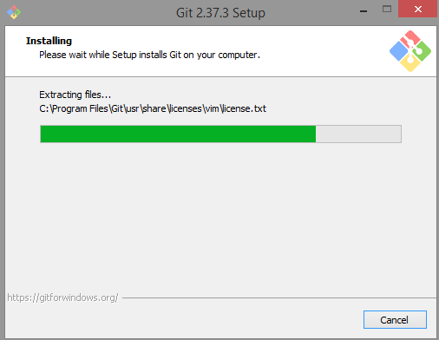

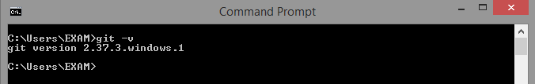

**Step 2:** Creating a new Git repository

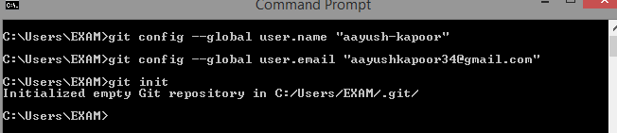

**Step 3:** Adding the file in the working directory

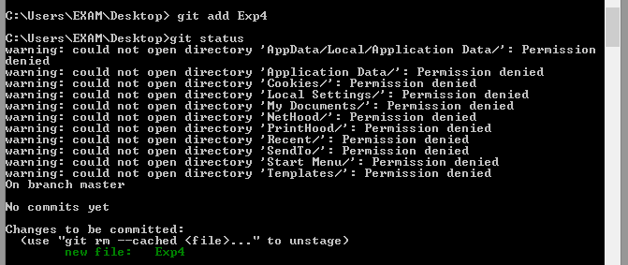

**Step 4:** Commiting the changes to the head repository

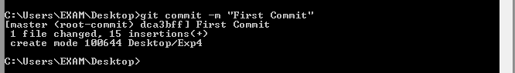

**Step 5:** Viewing the pushed file on github dashboard

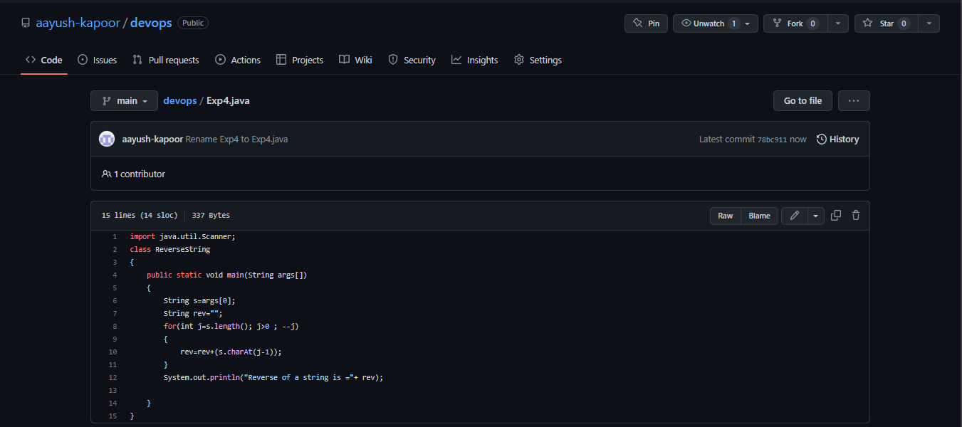

**Step 6:** Adding git plugin on Jenkins

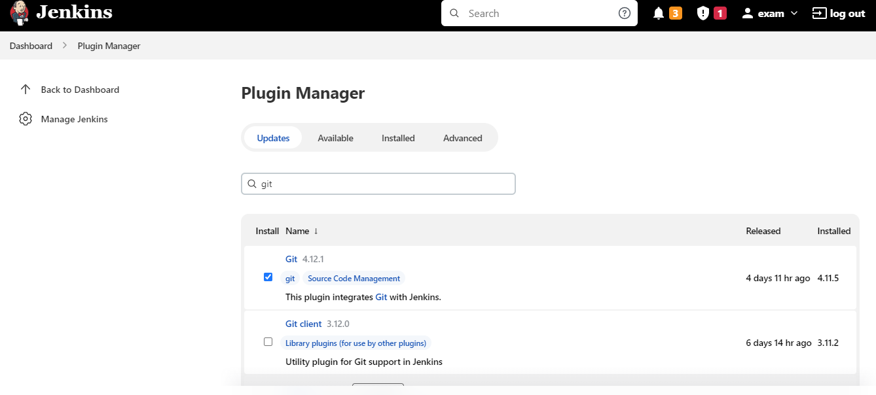

**Step 7**: Creating a project on Jenkins

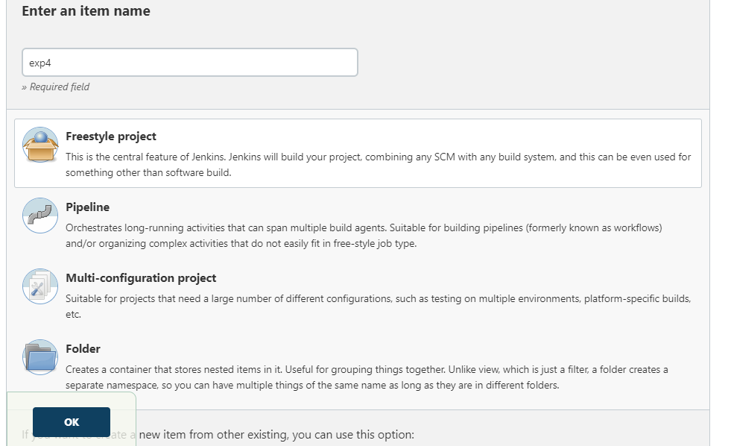

**Step 8**: Changing executable path

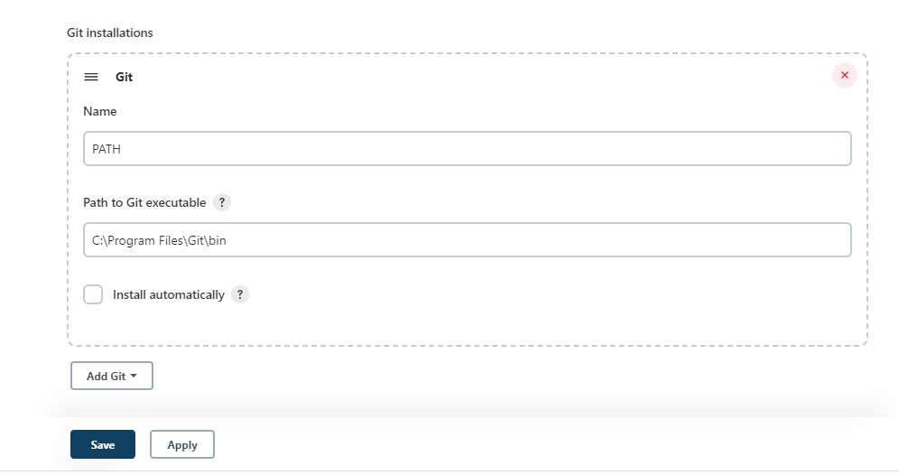

**Step 9:** Selecting git option in scm and entering url of repo

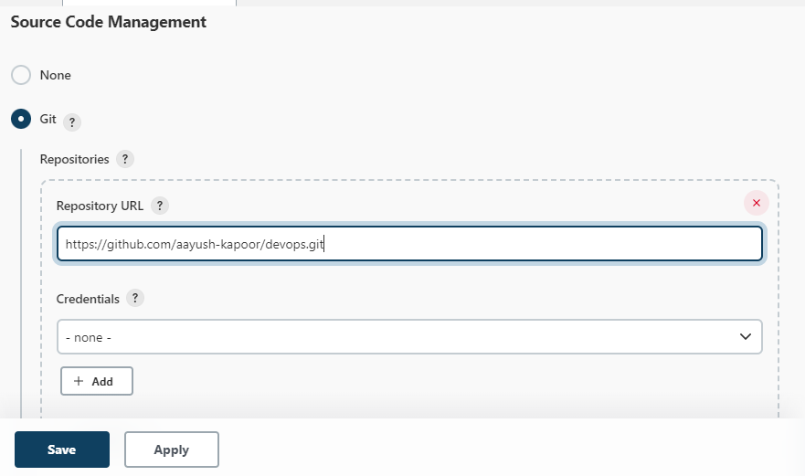

**Step 10:** Select poll scm in build triggers

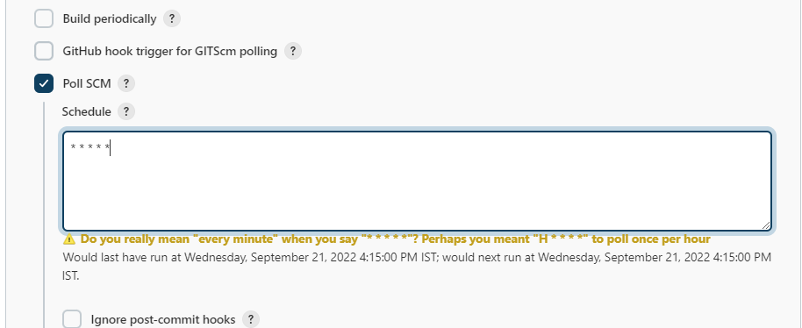

**Step 11**: Writing cli commands for executing java file and saving file

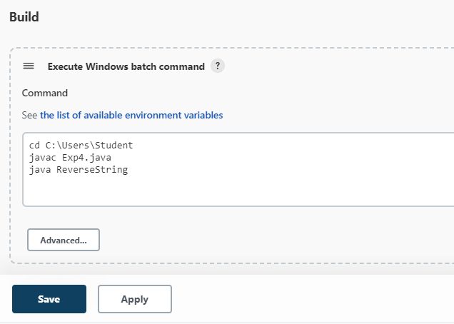

**OUTPUT**

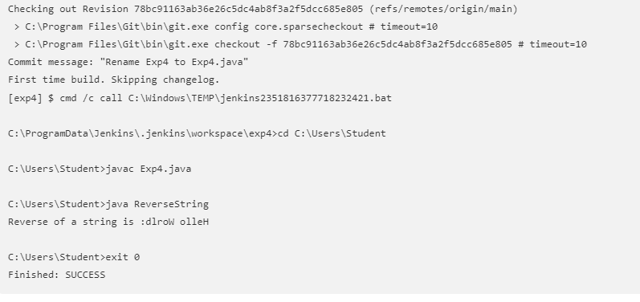

**Step 12**: Making changes in the code pushed on GitHub

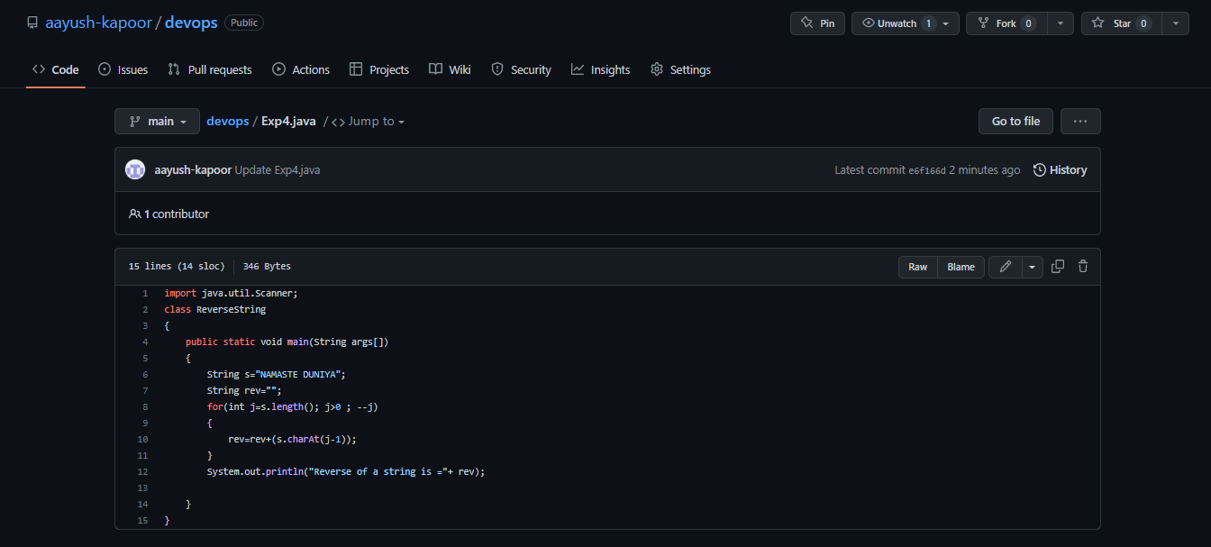

**OUTPUT 2**:

A new build is automatically started by the scm after pushing the changes and

the following output is displayed.

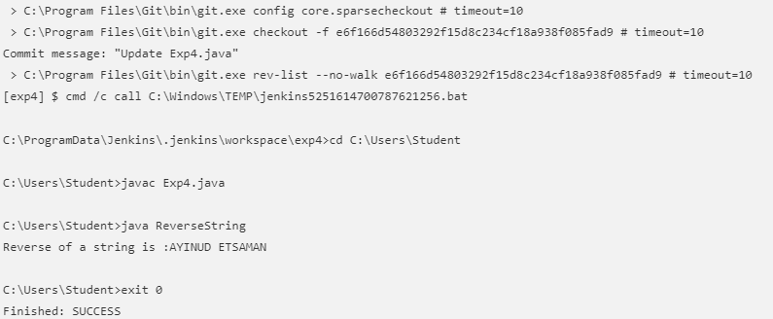

**Questions:**

1. What is difference between Git and GitHub?

**Ans.** Git is a version control system that lets you manage and keep track of your source code history. GitHub is a cloud-based hosting service that lets you manage Git repositories. If you have open-source projects that use Git, then GitHub is designed to help you better manage them.

2. What is Master and Branch in Github?

**Ans.**

MASTER - When you create a repository with content on GitHub.com, GitHub creates the repository with a single branch. This first branch in the repository is the default branch. The default branch is the branch that GitHub displays when anyone visits your repository. The default branch is also the initial branch that Git checks out locally when someone clones the repository. Unless you specify a different branch, the default branch in a repository is the base branch for new pull requests and code commits. By default, GitHub names the default branch main in any new repository.

BRANCH - Branches allow you to develop features, fix bugs, or safely experiment with new ideas in a contained area of your repository. You always create a branch from an existing branch. Typically, you might create a new branch from the default branch of your repository. You can then work on this new branch in isolation from changes that other people are making to the repository.

3. What is Jenkinsfile?

**Ans** A Jenkinsfile is a text file that contains the definition of a Jenkins Pipeline and is checked into source control. With JenkinsFile, you can write the steps needed for running a Jenkins pipeline. The benefits of using JenkinsFile are: You can create pipelines automatically for all branches and execute pull requests with just one JenkinsFile. You can review your Jenkins code on the pipeline.

**Outcomes:**

CO3: Comprehend the effective code building and testing process

**Conclusion: (Conclusion to be based on the Results and outcomes achieved)**

We learnt to integrate git with jenkins and autobuild applications as soon as changes are saved in the repository.